**Guidance Utility for Impaired Daily Experiences (GUIDE)**



*Critical Design Review*

GUIDE

Alyan Tharani

Jack Couture

Jack Letsinger

Noah Kilpatrick

Ryan Wu

Diana Canchola

Department of Computer Science

Texas A&M University

10/22/2024

Table of Contents

1 Introduction (1 page; 5 points) 2

1.1 Needs statement 3

1.2 Goal and objectives 3

1.3 Design constraints and feasibility 3

1.4 Validation and Testing Procedures 4

2 Proposed design (5-10 pages; 60 points) 5

2.1 Updates to the proposal design (if applicable) 5

2.2 System description (1-2 pages; 30 points) 5

2.3 Complete module-wise specifications (4-6 pages; 30 points) 7

3 Project management 21

3.1 Updated implementation schedule (1 page; 10 points) 22

3.2 Updated validation and testing procedures (1 page; 10 points) 24

3.3 Updated division of labor and responsibilities (2 pages; 10 points) 25

4 Preliminary results (1-2 pages; 5 points) 27

**5 References 28**

# Introduction (1 page; 5 points)

## Needs statement

The visually impaired population makes up around 285 million people all over the world, 50 million of which are completely blind according to the World Health Organization. Although there have been many innovations to accessibility and our infrastructure, it remains difficult to navigate certain environments such as university campuses. The current limitations for the visually impaired include the inability to detect obstacles in front of them and the distances of those obstacles. Knowing these two pieces of information can better aid the visually impaired in navigating college campuses, making higher education more accessible. The current solution involves static walking sticks that can signal the visually impaired if an obstacle is in front of them when the stick touches the obstacle. This design became collapsible but has not seen any other major changes since 1947. With the technology available today, the walking stick is in desperate need of an overhaul to allow users to have a better understanding of what the terrain is like and what is ahead of them rather than only knowing what the stick has touched.

## Goal and objectives

GUIDE is geared towards visually impaired individuals, serving as a means to detect obstacles and to provide feedback to the user to alert them of their surroundings. Through depth detection connected to a vibrating handle, GUIDE will inform the user of their surroundings and any obstacles in their way as well as the relative distance from the obstacle. It will allow for changing sensitivity to allow the user to have more control over their experience. GUIDE will provide real-time feedback with delays of less than 0.5 seconds to its users. It will allow for different metrics to be modified so users can tune the performance to their needs and wants. GUIDE will use a depth camera and LiDAR working in combination to detect obstacles 2 meters away and provide real-time feedback, allowing visually impaired users to navigate safely and independently in various environments. GUIDE will use affordable, high-quality parts and materials, and will not exceed the budget of $300. The design will not be intended to be replaced, but rather last as long as the warranties of the parts allow. GUIDE will be powered by commercially available batteries that can be replaced when out of charge with a battery life of 3-4 hours. In the event of a future iteration, it should include charging capabilities. GUIDE will be able to operate at any time of day, as well as both indoors and outdoors. While not completely submersible, it will be able to withstand small amounts of water in the event of rain or spills.

## Design constraints and feasibility

A major constraint as mentioned previously is the power supply. GUIDE will have to have the batteries manually replaced following a 3-4 hour use window. This is due to factors such as cost as well as structure. The current power supply is very cheap and easy to work with whereas a charging setup with a port can become very expensive very fast in order to fully implement. The $300 budget would instead be better spent on better LiDAR and other technologies that can improve the functionality of the device. Furthermore, having a charging set up in the walking stick or its handle leaves little room for other critical devices such as the vibrator motors and their wiring. So, to implement this, the walking stick would need to have an even larger handle and larger diameter of the stick, completely changing the structure of GUIDE. Thus, the objectives and goals we have set have focused on feasibility within the budget as well as ensuring the complexity does not exceed the amount of time we have to work with. Overall, the only other major constraint is the cost of technologies such as LiDAR. As mentioned, that is where we have decided to place most of our budget. This is because LiDARs are usually fairly expensive and with our budget, we cannot afford a top-of-the-line LiDAR. However, for this project to be feasible, we do need a LiDAR that can work efficiently and consistently in our system which is why it is a large chunk of our budget. With a larger budget, we could acquire a better LiDAR and maybe a better depth camera, but the project is still very much feasible under budget constraints.

## Validation and Testing Procedures

The validation and testing procedures for GUIDE are comprehensive and structured, spanning 3-4 weeks. The team has developed a three-step incremental testing approach, starting with individual component testing (e.g., serial port connectivity, power settings), followed by integrated tests of all components using a 5V power supply, and culminating in full system testing with the dedicated battery for the final product. A testing environment plan has been created, utilizing a prototype with a breadboard, spare Pico, and simulated sensor values. This setup allows for ongoing testing and code modifications while the final product is in production. The testing covers three key areas: mobility, obstacle detection, and user alerts. Mobility tests ensure the cane weighs less than 2 lbs, is collapsible, easily maneuverable, and functional for 3-4 hours. Obstacle detection is tested at distances of at least 2m, utilizing people and objects. Testing verifies that notifications occur within 0.5 seconds of obstacle detection, with vibration intensity increasing as objects get closer. This comprehensive approach ensures thorough validation of GUIDE's functionality and reliability.

# Proposed design (5-10 pages; 60 points)

## Updates to the proposal design (if applicable)

As development of GUIDE has progressed, changes to the design have been made due to the discovery of new information from hardware and software implementation. Our initial data engine relied on C++, since the Pico 2 has limited processing power. Through rigorous testing of the LiDAR and depth camera, Python was able to communicate more effectively with the sensors, allowing consistent data to be sent to the microcontroller. The LiDAR in particular has a very consistent output in packet format, with each packet containing 8 bits. Each packet starts with hex characters ‘YY’, with the data for length following in centimeters. The LiDAR was tested to detect at a high range with precision, and the detection range is more than sufficient for the previous design, so the parameters for the vibration strength will remain the same. The depth camera provides information about distance of objects from the sensor, but it does not have the level of precision as the LiDAR. However, the depth camera provides data of the environment it records, which is included in the packets that it sends to the Pico. With this information, more detail can be added in regards to the algorithms designed for GUIDE compared to the proposal design. The LiDAR can check if an object is in range of the user utilizing an algorithm that determines the distance of any object it detects. If an object is detected to be in range by the LiDAR, a machine learning algorithm is utilized to determine whether the object detected is considered an obstacle to the user. In regards to hardware, the design of the 3D-printed handle has gone through design changes, and specifications to what items would be located in the handle, in addition to their location in the handle, were implemented. Very small budget changes were made, although the total budget cost is very similar to that of the original proposal.

## System description (1-2 pages; 30 points)

Raspberry Pi Pico

The Raspberry Pi Pico serves as the central processing unit of the GUIDE system. It’s responsible for integrating data from various sensors, processing the information, and controlling the output devices. The Pico’s dual-core ARM Cortex-M0+ processor provides sufficient computational power to handle real time data processing from the LiDAR and depth camera. It also manages the communication between different components and executes the algorithms that determine when and how to alert the user about obstacles.

9V Battery

The 9V battery is the primary power source for the GUIDE system. It provides the necessary voltages to power all the components, including the Raspberry Pi Pico, sensors, and buzzers. The choice of a 9V battery offers a good balance between power capacity and size, allowing for a compact design while ensuring sufficient operating time for the device.

Buck Converter

The buck converter plays a crucial role in power management and transformation in the GUIDE system. It steps down the 9V voltage from the battery to the appropriate voltage levels required by the components. This voltage reduction ensures stable and efficient power delivery to all parts of the system, preventing damage to sensitive electronics from voltage fluctuations.

Buzzer

The buzzer is the primary output device in the GUIDE system. It provides tactile feedback to the user about detected obstacles. The buzzer can emit different intensities or patterns of vibration to convey information about the distance and nature of the obstacles. This feedback is crucial for users with visual impairments who rely on non-visual cues for navigation.

Depth Camera

The depth camera is a key sensor in the GUIDE system, providing detailed 3D information about the environment in front of the user. It captures depth data, allowing the system to create a three-dimensional map of the surroundings. This information is crucial for detecting obstacles, understanding their size and shape, and determining their distance from the user. The depth camera's data is processed by the Raspberry Pi Pico to provide accurate and detailed obstacle detection.

LiDAR

The LiDAR (Light Detection and Ranging) sensor complements the depth camera by providing highly accurate distance measurements. It uses laser light to measure the distance to objects with high precision. In the GUIDE system, the LiDAR data is used in conjunction with the depth camera data to create a more robust and accurate obstacle detection system. The LiDAR is particularly useful for detecting obstacles at longer ranges and in various lighting conditions.

3D Printed Handle and Housing

While not electronic components, the 3D-printed handle and sensor housing are integral parts of the GUIDE system. The handle ergonomically houses the Raspberry Pi Pico, battery, buck converter, and buzzers. It's designed for comfort and ease of use, allowing the user to easily grip and manipulate the device. The sensor housing securely holds and protects the LiDAR and depth camera, ensuring they maintain proper alignment for accurate obstacle detection.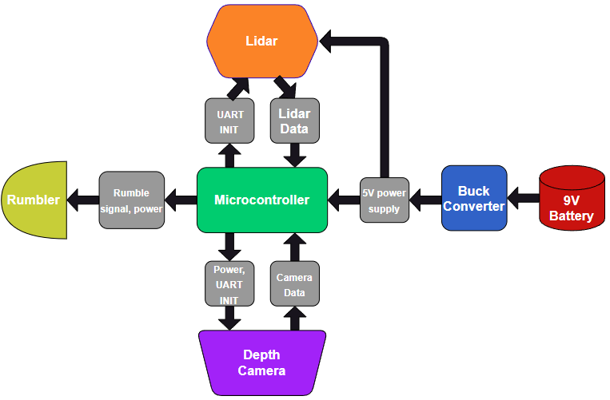

*Figure 1: Block Diagram of the GUIDE System*

## Complete module-wise specifications (4-6 pages; 30 points)

* + 1. Hardware

**Circuit and logic diagrams**

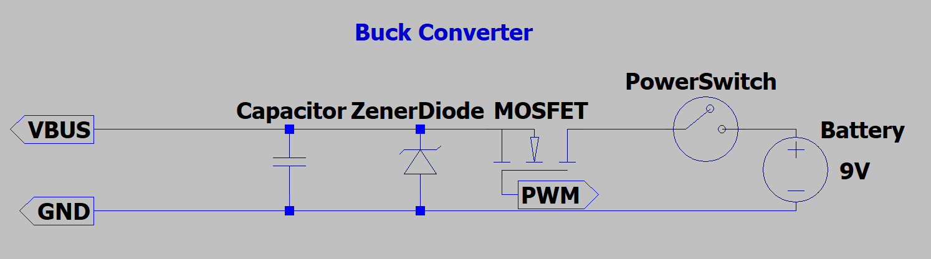

*Figure 2: Circuit diagram of the Buck Converter utilized by GUIDE system.*

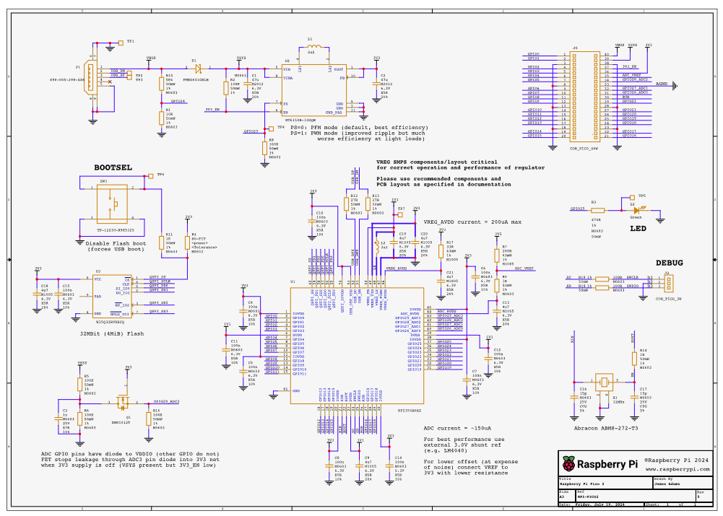

*Figure 3: Circuit diagram of Raspberry Pi Pico*

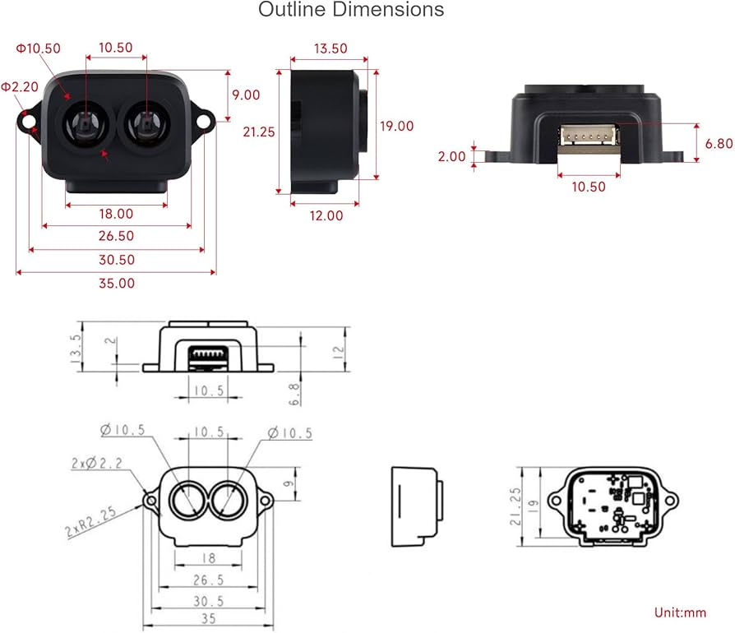

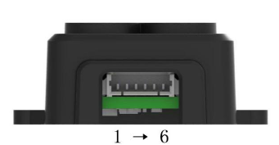

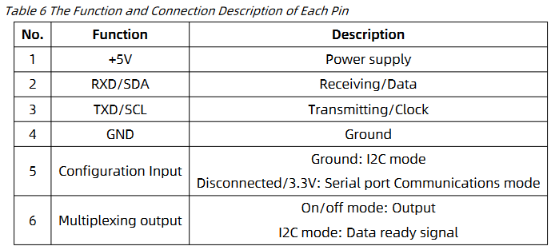

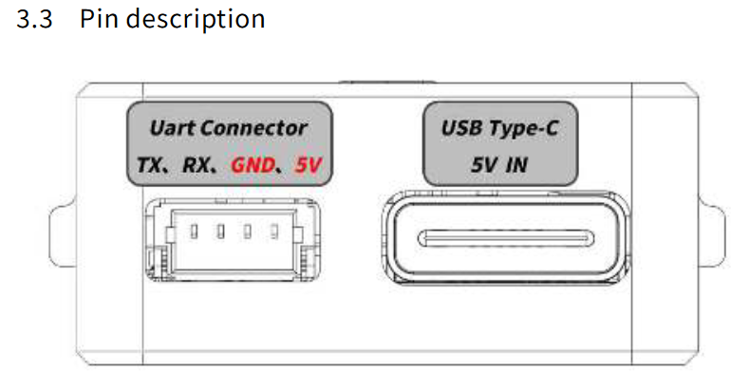

**Interfaces and pin-outs**

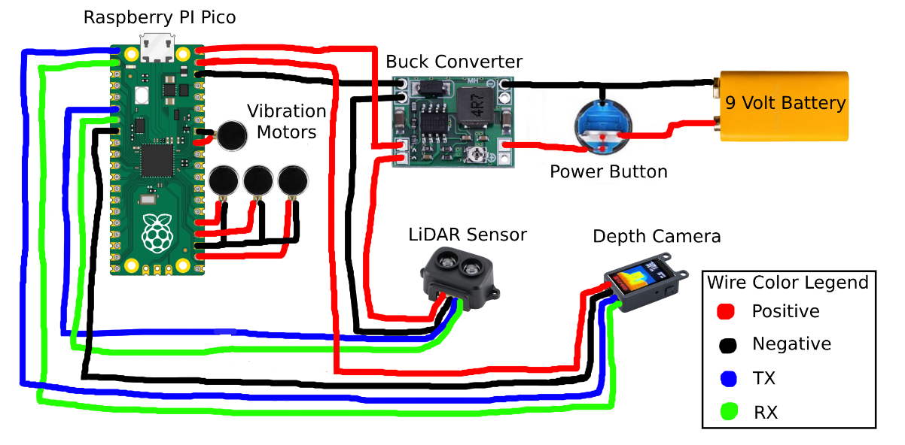

*Figure 4: Pinout diagram of GUIDE system. The system includes the microcontroller, the Raspberry Pi Pico, the electronic sensors, LiDAR and depth camera, the power distribution modules such as the battery and buck converter, and finally, the power button.*

**Timing diagrams and waveforms**

The response time of the sensors is a critical part of this project. Our initial target reaction time of 0.5 seconds (500ms) from the proposal was generous, and current data collection testing indicates that we will be well within the specification.

|  | No Lidar | Lidar |
| --- | --- | --- |
| No Depth Camera | N/A | 9.97 ms |
| Depth Camera | 21.98 ms | 44.14 ms |

*Table 1: This table outlines the response times of the LiDAR sensor and Depth Camera.*

It is interesting to note that the LiDAR had an average faster response time. Additionally, both sensors had a little to no response variation, with the depth camera ranging between 19 and 25 ms, and lidar ranging between 8 and 11 ms when tested individually. However, having both sensors collecting data at once (with limited cpu resources), makes the average data response around 44ms. Assuming a worst case scenario of 50 ms response time, this is still 10x faster than the proposed number.

While this testing is valid and within spec, these timings include the time needed to print out the telemetry data. Print statements and if/else statements in the program logic can eat up time and resources, so disabling them in the final build will probably allow for an untestable but respectable performance boost.

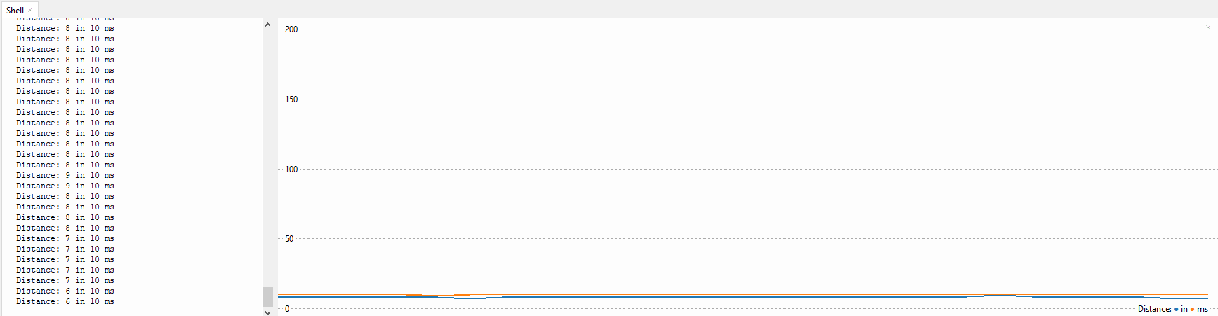

Object distance from Lidar and response time in milliseconds as a function of time.

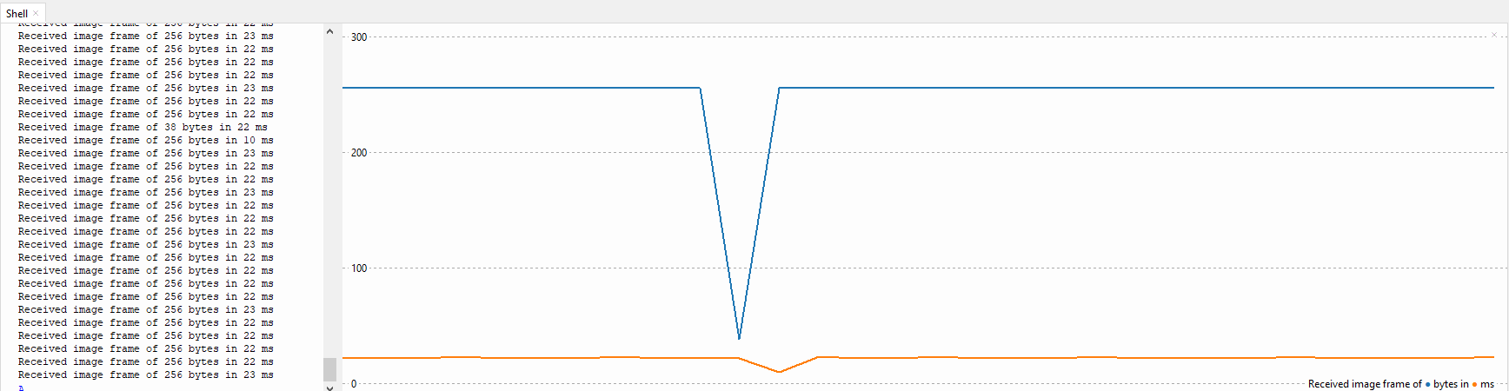

Packet Size from Depth Camera and response time in milliseconds as a function of time.

As per the graph, all feedback is internally relayed and output via a LED/Buzzer within the handle. The timings are very consistent, with dips or dropped bytes being only a result of the tail end of a packet from one of the sensors.

**Software processes with their inputs and outputs**

Here is the current source code implementation:

from machine import UART, Pin

import utime

import struct

led = machine.Pin(25, machine.Pin.OUT)

buzzer = machine.Pin(15, machine.Pin.OUT)

# Initialize UART on GP0 (TX) and GP1 (RX)

uart0 = UART(0, baudrate=115200, tx=Pin(0), rx=Pin(1)) # LiDAR

uart1 = UART(1, baudrate=115200, tx=Pin(4), rx=Pin(5)) # Depth Camera

Here is the initialization of both UART ports on the Pi. While the Pico has 2 UART ports that can be wired up in 5 different locations, each sensor needs to be on a different UART channel in order to prevent data miscommunication.

There are still a few parameters of the UART class from the machine library that will be worth going through in order to make the project more accurate and power efficient.

def send_at_command(command): # send configuration settings to the depth camera

uart1.write(command + '\r')

utime.sleep_ms(100) # Wait for response

response = b''

if uart1.any():

response += uart1.read()

print(f"Command: {command}, Response: {response}")

return response

def initialize_camera():

send_at_command("AT+ISP=1") # Turn on ISP

send_at_command("AT+DISP=4") # Enable UART display

send_at_command("AT+SAVE=1")

Here is the depth camera initialization and communication protocol. As per the documentation, several settings must be enabled and saved to ensure the camera is working properly. The UART Python class makes this exceptionally readable and easy to implement. The print statements will be taken out of the final build, as it will not be readable. Note that there is No LiDAR setup function, as it is by default in the correct configuration and requires no changes.

def read_lidar():

try:

if uart0.any():

data = uart0.read()

if len(data) >= 7 and data.startswith(b'YY'):

distance = struct.unpack('<H', data[2:4])[0]

print(f"Distance: {distance}", end=" ")

return distance

else:

print("Incomplete or invalid frame")

return None

except Exception as e:

print(f"Error: {e}")

return None

return None

def read_camera():

try:

if uart1.any():

data = uart1.read(256)

print(f"Received image frame of {len(data)} bytes", end=" ")

return data

except Exception as e:

print(f"Error: {e}")

return None

Here are the lidar and depth camera read functions. For the LiDAR, the exact bytes that determine distance have been figured out and are decoded every function loop. While we understand how to process the Depth Camera data over the UART, the software implementation in python has not yet occurred, as it was not necessary for the full proof of concept for the breadboard prototype.

print("Initializing camera...")

initialize_camera()

# Main loop

while True:

try:

distance = read_lidar()

if distance is not None:

if distance < 100:

led.value(1)

buzzer.value(1) # Turn on the buzzer when LED is on

else:

led.value(0)

buzzer.value(0) # Turn off the buzzer when LED is off

image_frame = read_camera()

except Exception as e:

print(f"Error: {e}")

As previously mentioned, while the camera data can be properly configured and read, we are still in the implementation phase of utilizing it as intended. With the setup of the GPIO pins in the header, toggling the values of an LED or Buzzer as a result of incoming data is clear and easy to implement. While using C or C++ would result in improved memory and power consumption, as well as better performance, the ease of python as an interpreted language and high level of abstraction make it easy to debug and prototype the sensors, with suitable performance as a tradeoff. If we were to discover that a python or non-C approach was too slow, we would approach the project differently and make changes as needed.

Example data coming from LiDAR:

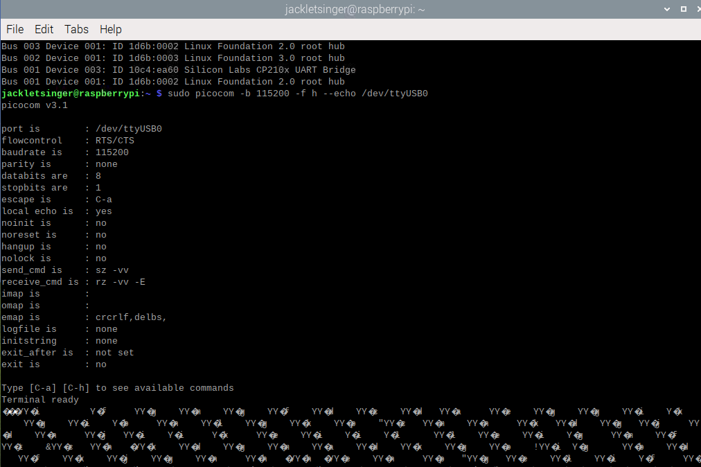

Initial data coming from the LiDAR through a UART bridge to a Linux machine was not promising. Data would arrive in inconsiderate bursts, with null and undefined ASCII characters in and around data packets. This made it difficult for our software team to get a foothold on the data gathering component of the project.

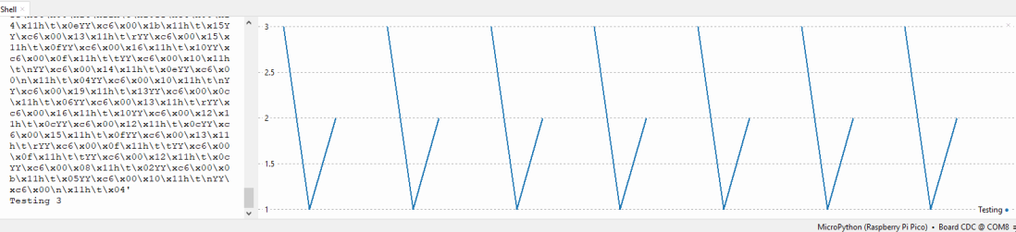

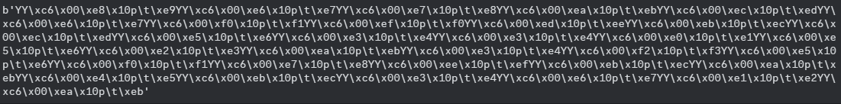

Despite issues running connected to a computer, the LiDAR worked perfectly on the Pi Pico.

Example data coming from Depth Camera

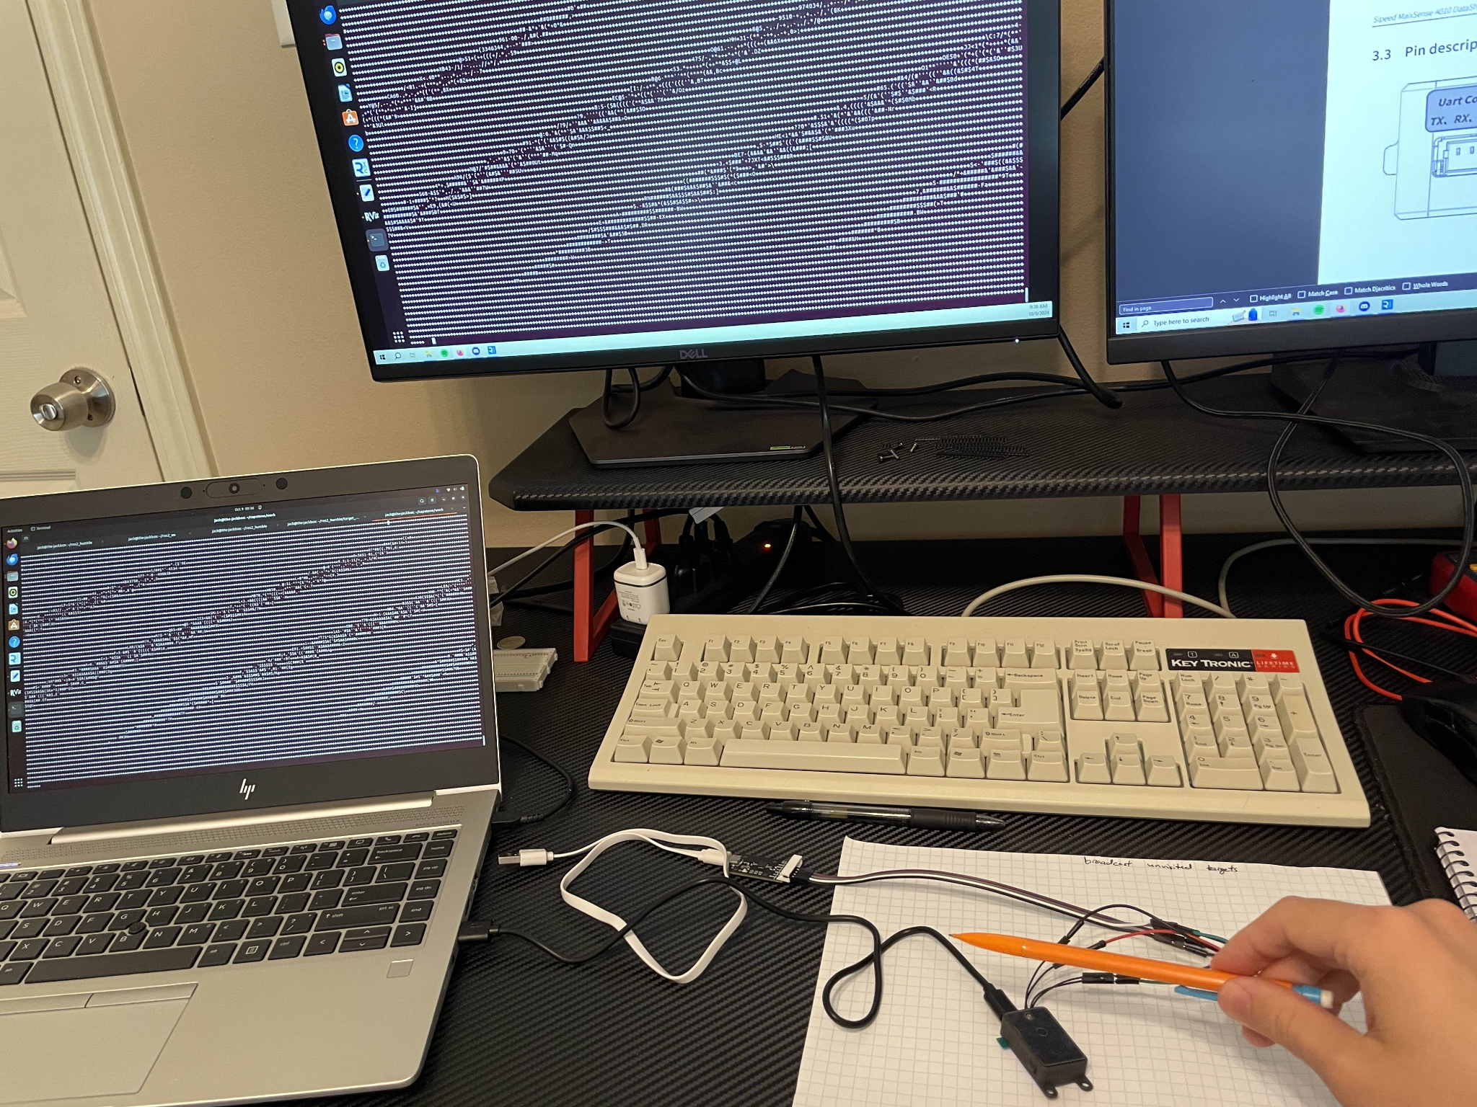

*Figure 7: Early stages of Depth Camera development before decoding data packets.*

The Depth Camera has a LCD display that shows a heatmap of the image it takes in, as well as the frame rate. The Data piped through the Pi however is an ASCII representation of the image, with a header that could potentially indicate a distance and other useful telemetry for this project.

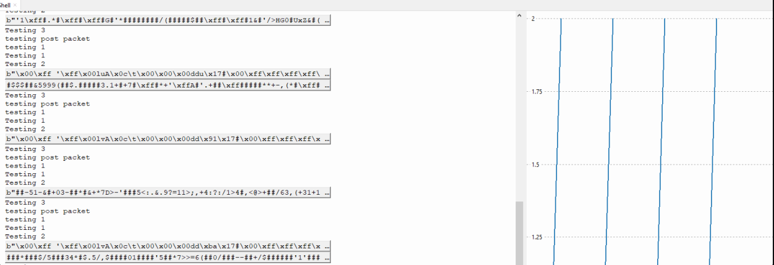

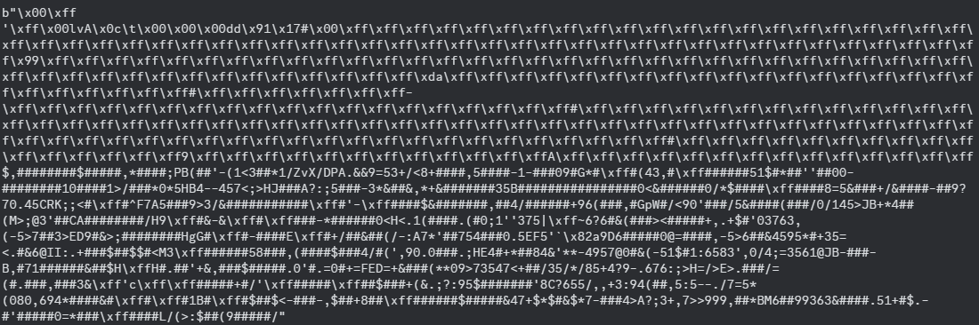

GUIDE Parts List

|  | Amount | Amount per Unit | Cost per Unit | Dimensions | Weight | Total Amount ($) |
| --- | --- | --- | --- | --- | --- | --- |
| Walking Stick | 1 | 1 | $17.99 | 53in x 0.5in - Rod  7in x 1in - Handle | 0.55lb | $17.99 |
| Power Button | 1 | 1 | $9.99 | 16mm | 0.35 ounces | $9.99 |
| Vibrating Motor | 2 | 8 | $7.59 | 10mm x 2.7mm | 0.63 ounces | $7.59 |
| LiDAR | 1 | 1 | $23.99 | 10mm x 2.7mm | 0.176 ounces | $23.99 |
| Depth Camera | 1 | 1 | $43.00 | 10mm x 2.7mm | 10.6 ounces | $43.00 |
| Buck Converter | 1 | 6 | $1.67 | 22mm x 17 mm | 3g | $10 |
| Raspberry Pi Pico 2 | 2 | 2 | $6.25 | 21mm x 51mm | 4g | $12.50 |
| 9V Battery Holder | 1 | 10 | $0.50 | 0.94"L x 0.47"W x 0.28"H | <1g | $4.99 |
| 9V Battery (Rechargeable) | 1 | 4 | $5.25 | 48.8mm x 26.0mm | 0.12kg | $20.99 |
| PLA Printer Filament | 1 | 1 | $0.055 (per g) | N/A | 63g | $3.50 |
| Angle Adjuster | 1 | 1 | $13.99 | 2.95” x 2.56” x 0.98” | 0.09kg | $13.99 |
| Total (s) | N/A | N/A | N/A | N/A | 44.72 oz or 2.795 pounds | $168.53 |

*Table 2: Completed list of parts ordered for GUIDE.*

* + 1. Software

The software systems in place read a CSV file collected by the depth camera or the LiDAR and take the hex bytes to convert the data into standard assignments. This involves taking in a collection of bytes and deciphering the header and any data relevant to the capture device such as distance in different axes and other provided data. The software converts this hex to integers so that the values can be easily understood and manipulated using standard integer calculation rather than trying to work in hex. Originally, this data was then pieced together into frames in order to recreate what the capture device was seeing. However, this data will be collected and compared to determine which capture device is more accurate in different situations. The plan is to have an artificial intelligence system and machine learning that has been fed data from both capturing systems as well as the measured distances so that it can determine when to use the distance from which device or determine an algorithm that works best. This could involve a weighted average with the depth camera or LiDAR being considered more accurate in certain situations. For now, we are focused on moving the software onto the actual device and running it with live data. This will involve taking in the bytes in real-time and simply determining the distance. Finally, we originally were using C++, but with recent hardware changes, all code moving forward will be in Python with any remaining C++ scripts being rewritten. Below are two examples of important functions in our code that will be converted to Python and implemented using Python libraries rather than C++:

for (int i = 0; i < 16; i++) {

std::getline(ss, byte, ',');

int value = hexToInt(byte); // Convert hex string to integer

row_data.push_back(value);

}

This code is used to actually read from Byte0 to Byte15 with a line in a previous part of the code skipping the first byte as that is the header. These bytes contain critical information such as distance in the axes and image data that can be used for calculations as well as generating images or video. It also calls another important function that is shown below:  
  
int hexToInt(const std::string& hexStr) {

int value;

std::stringstream ss;

ss << std::hex << hexStr;

ss >> value;

return

This simple function takes in the hex data and converts it to an integer when called so that the value may be more easily manipulated and understood as mentioned before. Overall, these two functions drive a lot of the basic but very important processes when receiving data with the LiDAR or the depth camera and we hope to have a system in place to allow both capture devices to work together as soon as possible.

* + 1. 3D Modeling

Table 1: Material used in CAD prototyping

|  | Amount | Amount per Unit | Cost per Unit | Total Amount ($) |
| --- | --- | --- | --- | --- |
| PLA Printer Filament | 63g | 63 | $0.055 (per g) | $3.50 |

*Table 3: 3D printing prices for GUIDE handle.*

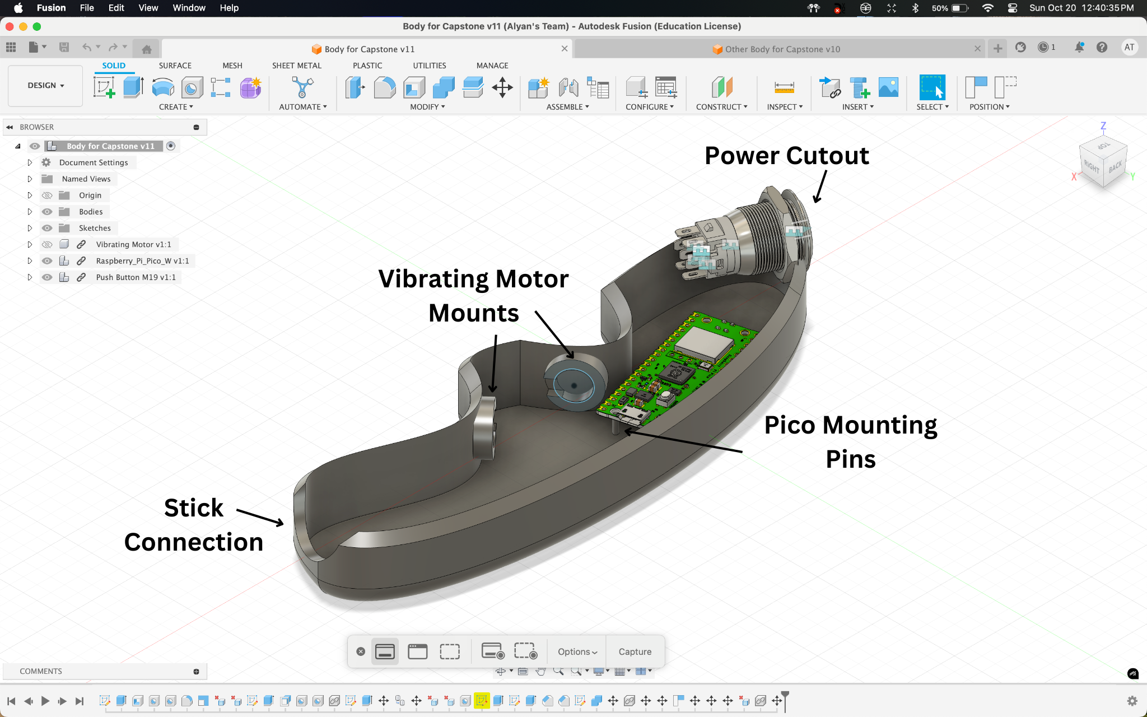

*Figure 8:* CAD for left side of handle body. This body includes pins for Raspberry Pi Pico Mounting, cutouts for power button and stick connection, and there are also cutouts for 2 vibrating motors. Further, this is a mirror copy of the right side, and we have printed out an example print shown in *Figure 10-11.*

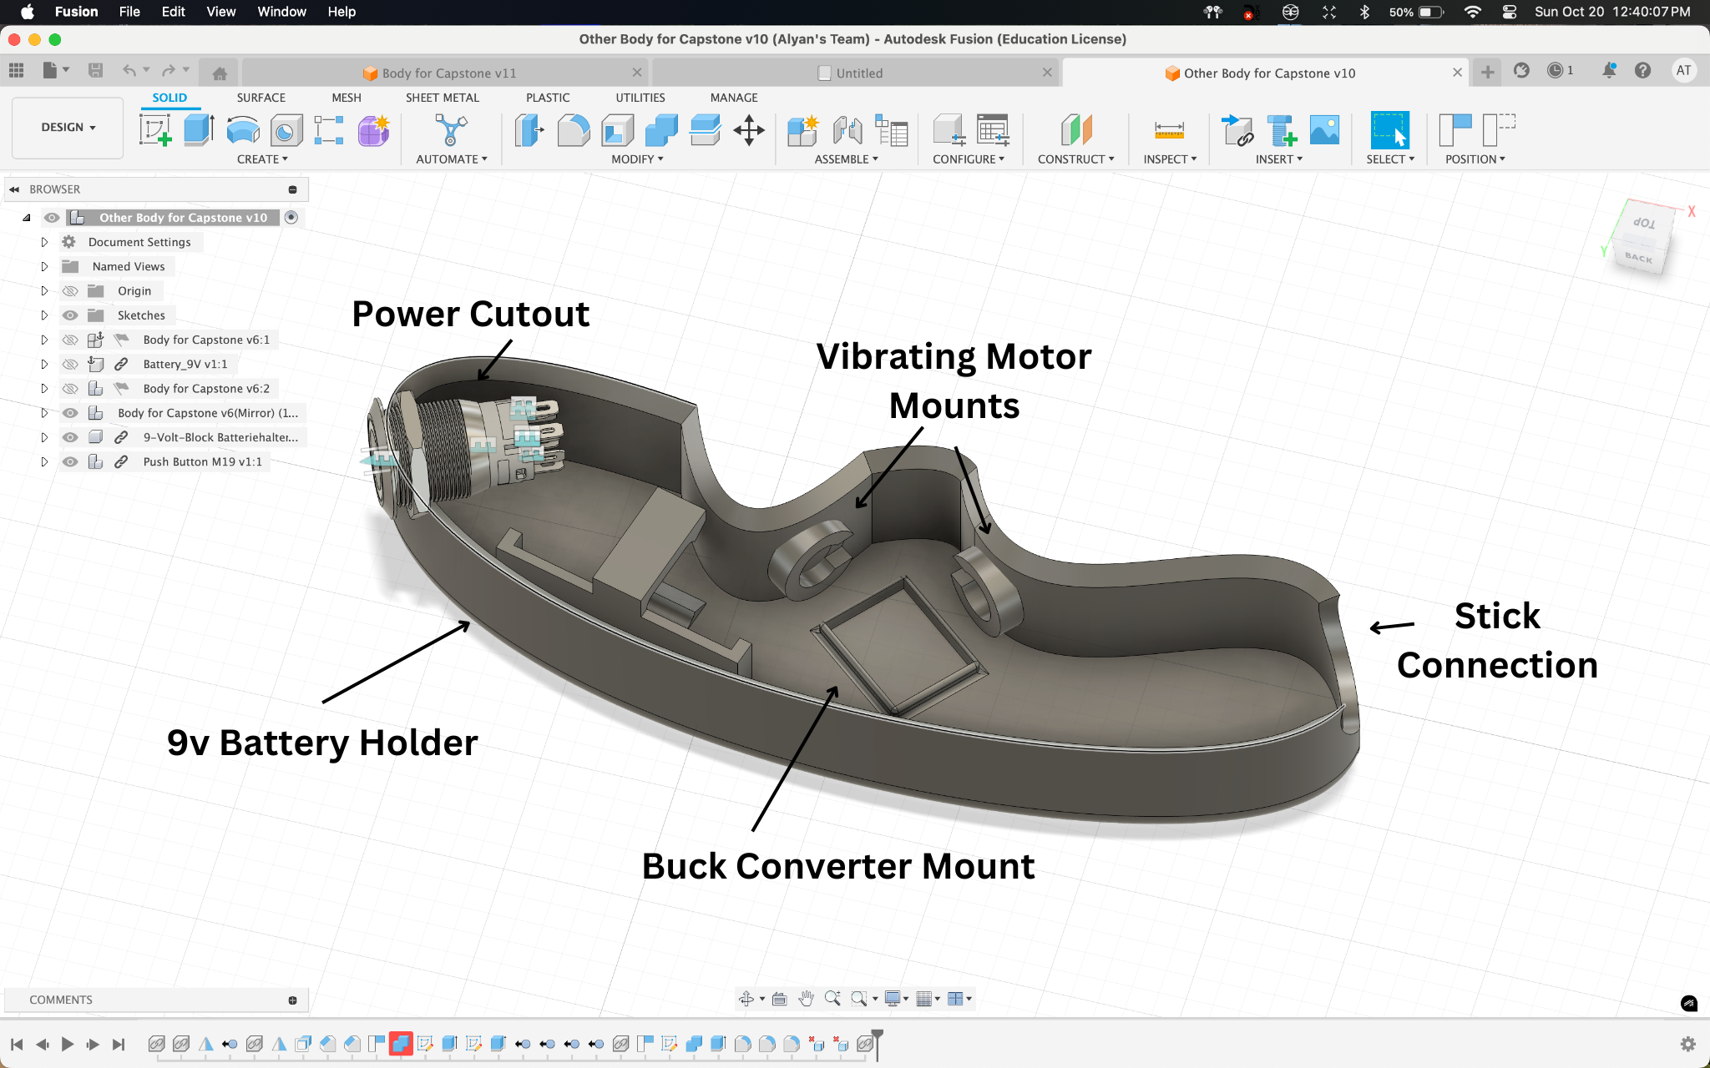

*Figure 9:* CAD for right side of handle body. This body includes a mount for the Buck converter which allows us to drop the voltage from the 9v battery to 5v. It also includes a battery mount, two vibrating motor mounts, and cutouts for the walking cane connection and a power button cutout. Further, this is a mirror copy of the right side, and we have printed out an example print shown in *Figure 10-11.*

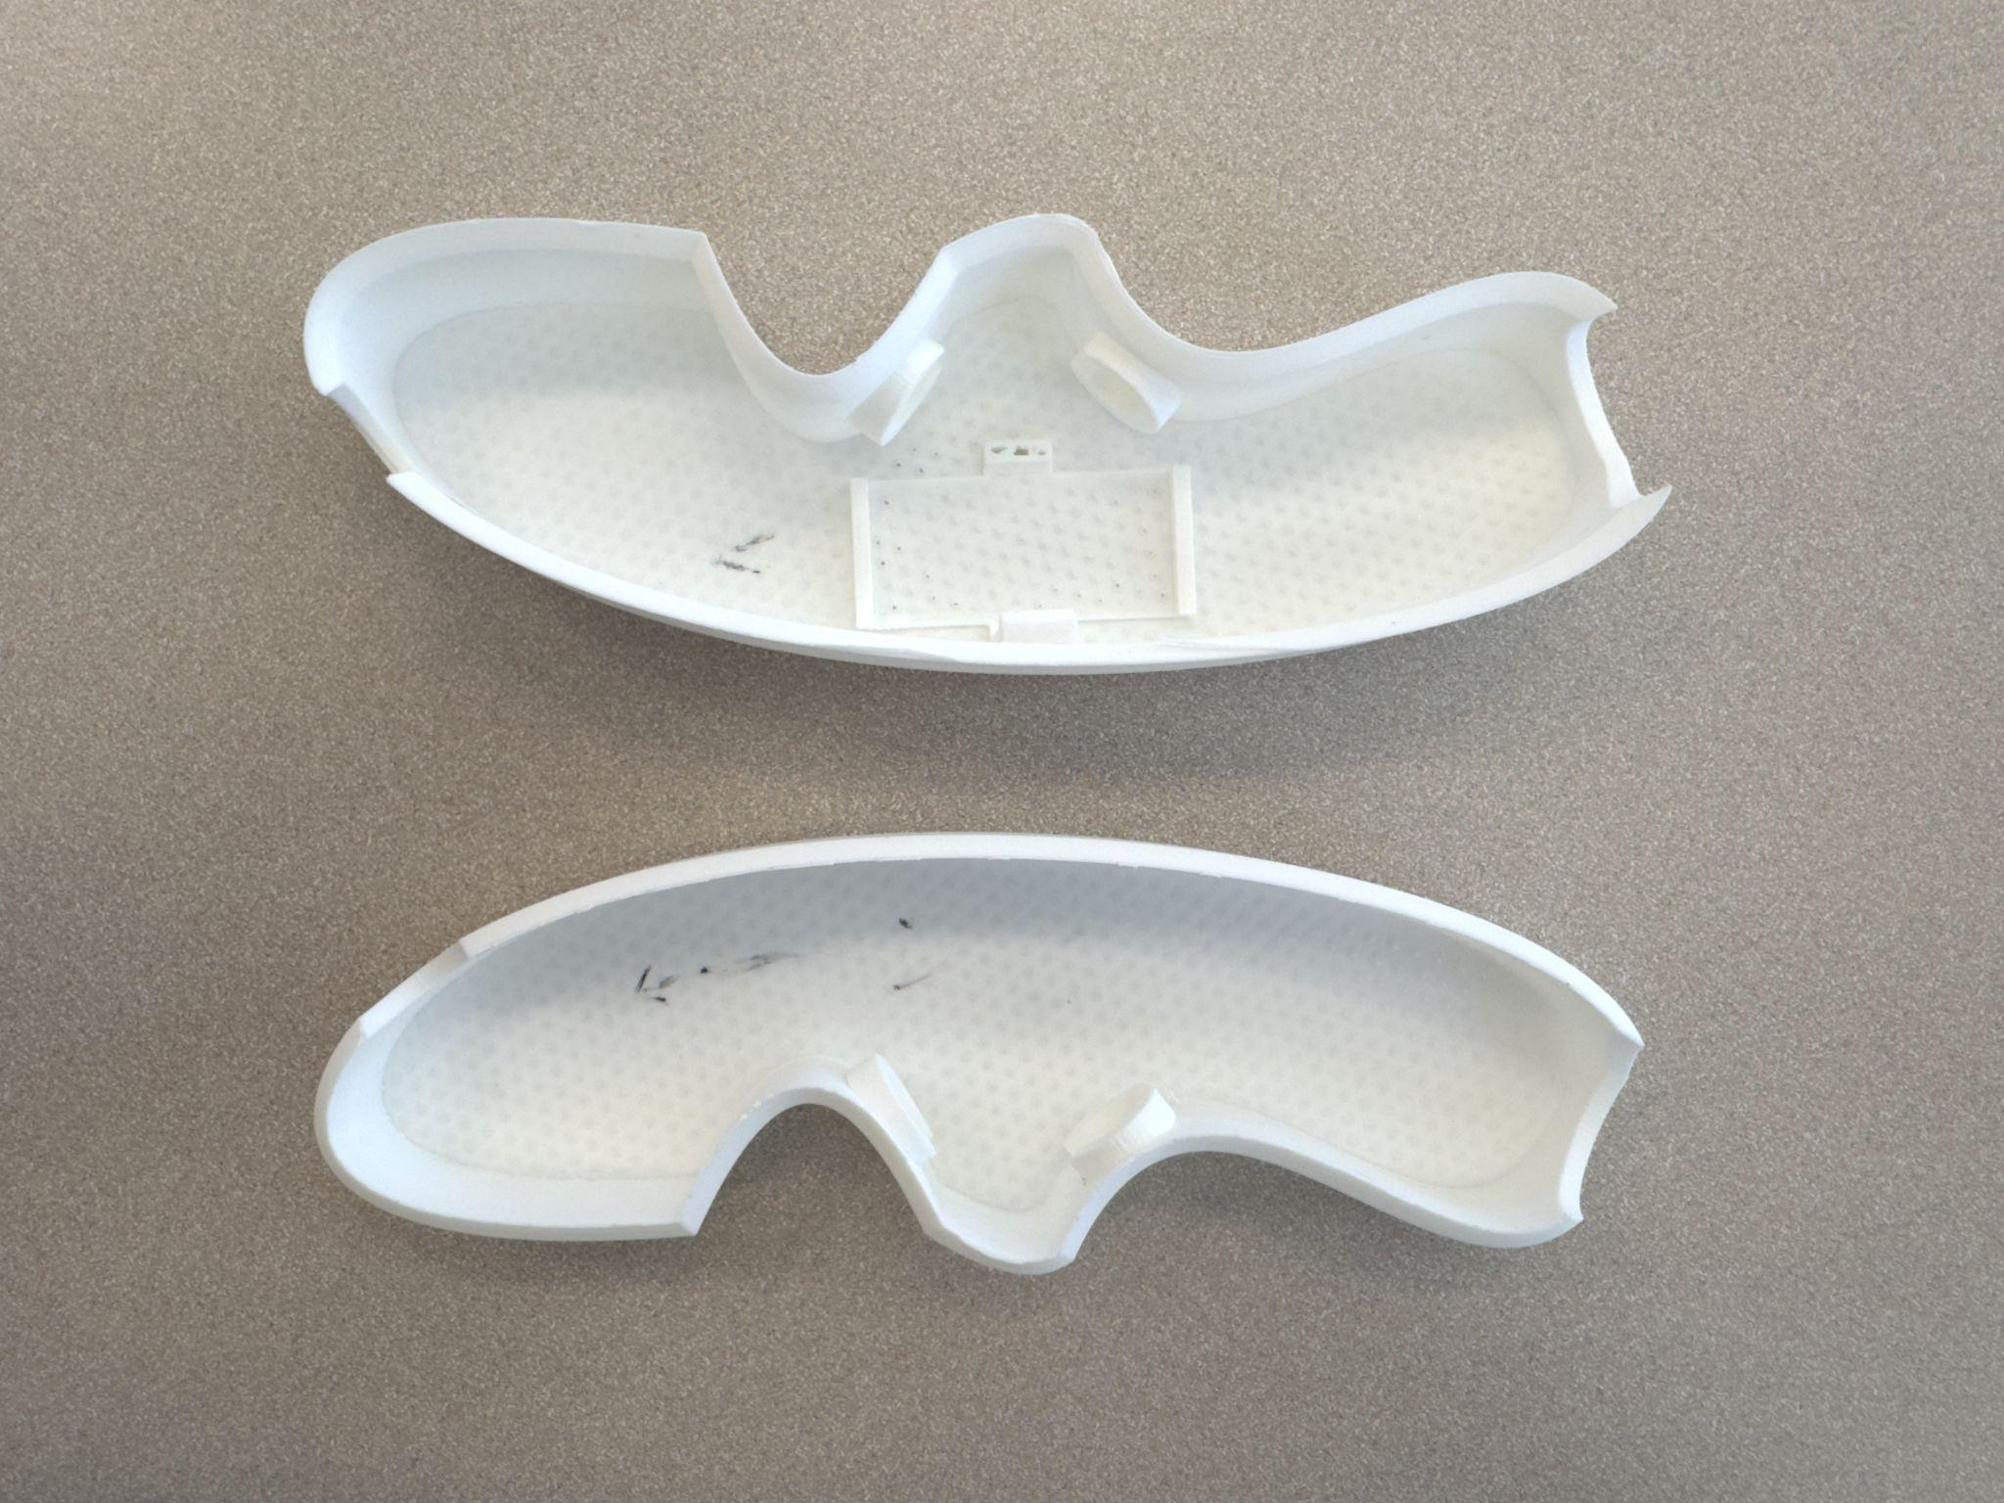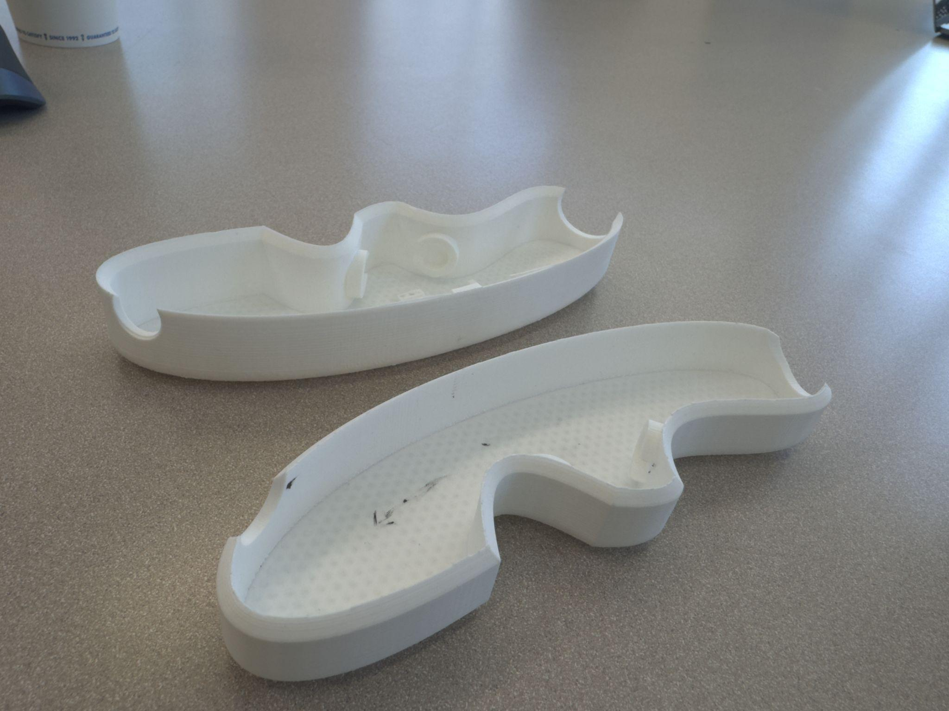

*Figure 10-11:* This is the first prototype we printed for the handle, as you can see from *Figure 2-3*, we have made quite a few changes based off our updated constraints and requirements

# Project management

The GUIDE team is composed of 6 members, 3 of which hold the position of a team lead, a software lead, and a hardware lead. The team is split in half where three members work on hardware and the other three work on software. The team meets 2-3 times a week, once with the professor to discuss current progress made. We have development meetings on Thursdays and Fridays to work through any hardware development and use the physical components to test software. To develop software outside of meeting times, the hardware lead sets up a virtual machine. We have a discord channel where individual progress is tracked and any roadblocks are addressed. This management approach is working as it allows the team to work together as well as develop their own parts on their own time. The only improvement to be made moving forward would be adding additional time during the week to meet as we start the design validation process.

Diana Canchola - Team Lead

As the team lead, Diana oversees the overall project and its direction. Her job is to ensure that we are on schedule and meeting all required deadlines, while also facilitating communication between team members. Additionally, she makes sure that our priorities are aligned, as the project spans only one semester. Diana is responsible for high-level decision-making and will assist both the hardware and software teams but focus on aiding the software development of GUIDE.

Jack Couture - Software Lead

As the software lead, Jack is focused on writing the control algorithms for GUIDE, interpreting distances, and processing the data from the distance cameras to generate outputs for the user. He will also manage the communication interface between the hardware and software, working closely with Jack Letsinger, the hardware lead. Additionally, Jack will continue to test the software components to ensure both reliability and accuracy in the system.

Jack Letsinger - Hardware Lead

As the hardware lead, Jack is responsible for selecting and integrating the components used in the system, such as distance cameras, vibration motors, and microcontrollers, ensuring compatibility and functionality. He will oversee the hardware development and manage testing to meet performance specifications. He has worked on creating a breadboard prototype of GUIDE and testing the sensors. Jack has taken lead over selecting and purchasing the components of GUIDE.

Alyan Tharani - Hardware Developer

As part of the hardware team, Alyan will be responsible for hardware integration and system design. Additionally, he has developed 3D-printed parts and provided them to the team for the tool’s construction. He will also work on assembling the hardware components, ensuring flexibility in the design of the camera mounts and other elements. Alyan will help with system testing and validate the system’s performance across different environments.

Noah Kilpatrick - Software Developer

As part of the software team, Noah will be responsible for developing the software, including coding control algorithms for the microcontrollers and integrating sensor data into actionable feedback. He will work closely with the hardware team to ensure that the software runs smoothly and meets performance objectives, such as low latency. He has helped the team decode data packets from the electronic sensors to parse data.

Ryan Wu - Hardware Developer

As part of the hardware team, Ryan will focus on assembly and ensuring compatibility with the software systems. Ryan has aided in the development of the breadboard prototype of GUIDE through getting our components such as the microcontroller and sensors ready for development and testing. Ryan has conducted feasibility tests on our electronic components.

## Updated implementation schedule (1 page; 10 points)

The charts below outline the schedule for our projects. The Gantt chart expresses the high level milestones we have completed and are yet to complete for the semester. Currently, we are finished with the breadboard prototype and will work to complete the software prototype. In this period we will also finalize our 3D modeled design, print it, and add all components to begin the design validation stage.

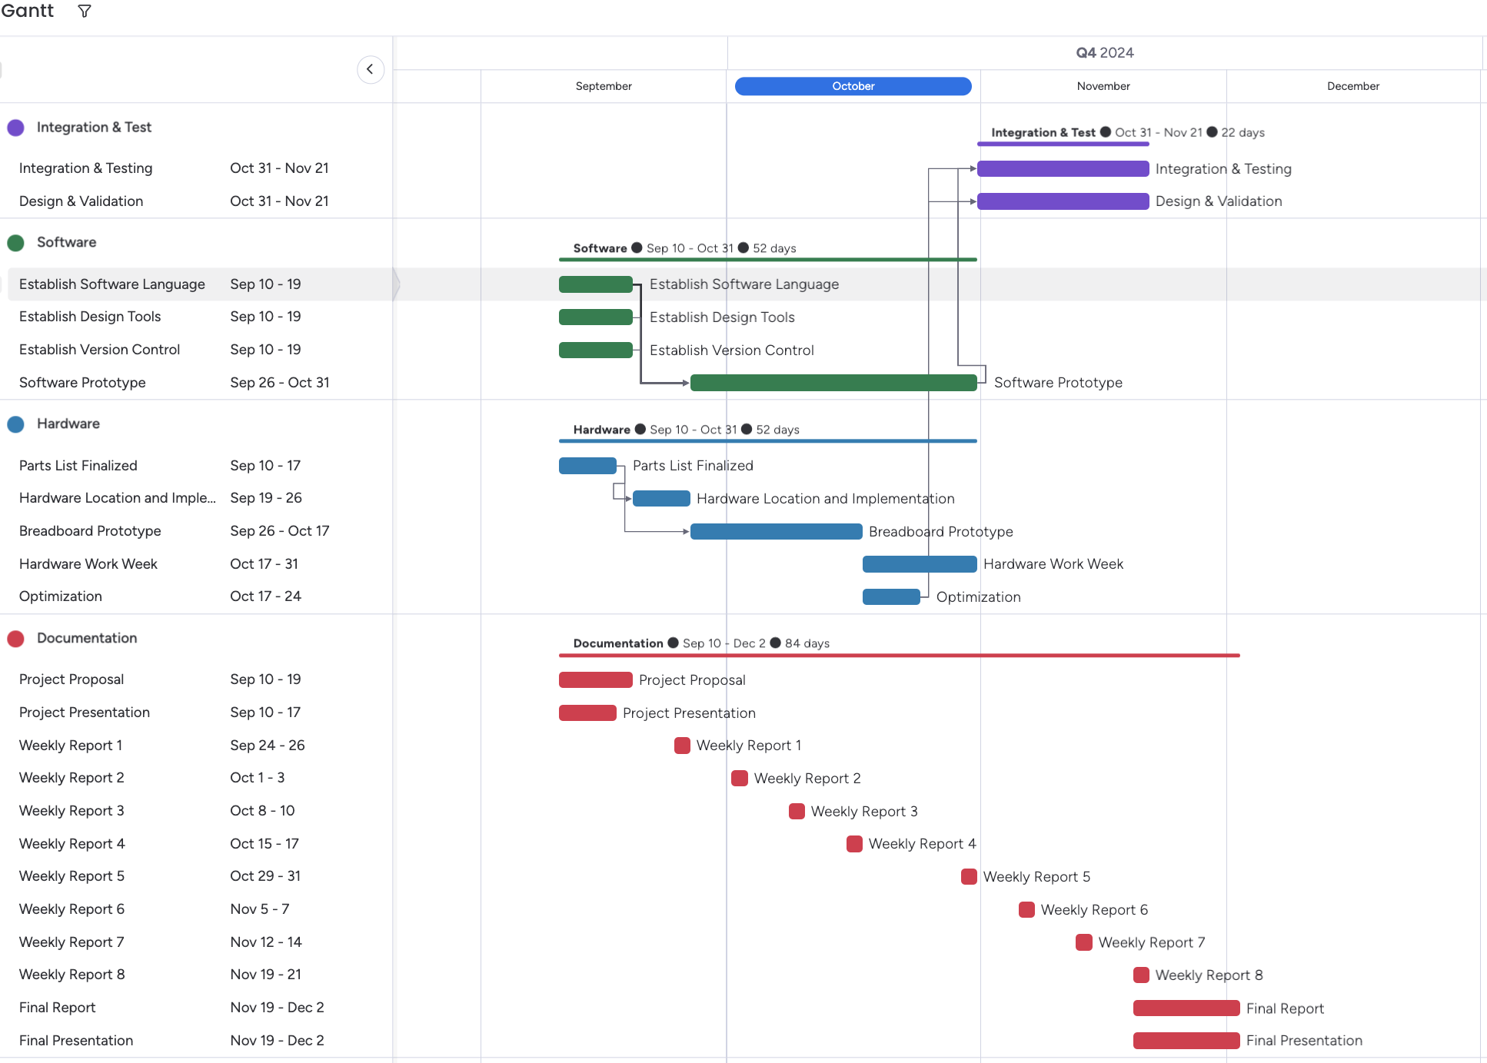

*Figure 12:* Gantt chart for the project schedule. This schedule is divided into four categories, documentation tasks, hardware tasks, software tasks, and integration & testing tasks. The chart has been updated to reflect current progress of the project. The changes made were elongating the breadboard prototype tasks for the Hardware section as the team attempted to implement best practices and co-design the 3D parts. Due to this elongation, the software prototype timeline was also elongated.

The Pert chart below highlights the implementation breakdown of GUIDE. The chart is broken down into Hardware, Software, Documentation, and Testing & Validation stages.

Currently, we have completed the planning portion of both the hardware and software development. The breadboard prototype has been completed as all components have been soldered, the UART bridges for all sensors has been established and we have solidified the batteries to be used and the buck converter to distribute the correct voltage. The software prototype has been a slower progress as the subteam was waiting for the breadboard prototype to complete. Currently, both sensor data packets have been decoded and the subteam will work on aggregating the data, integrating the haptic sensors, and begin creating a smarter decision making engine.

The next implementation steps for the Hardware team include finalizing the design of the handle as well as the sensor housing which will all be 3D modeled. The next implementation steps for the software subteam will be to incorporate the haptic sensors and develop a smarter algorithm to combine the two sensor readings. This smarter algorithm could be a trained machine learning algorithm. This algorithm would be trained around several areas of campus to ensure accurate data readings and a robust system. Finally, the team will enter the data validation stage where we will test the prototype around Texas A&M University and test if the two sensors are able to detect obstacles within a 2m distance and alert the user. We will test the weight and maneuverability of the rototype by using it for 1-2 hours. Lastly, we will package up the software deliverables located within the Pico, and complete the GUIDE prototype for a demo, final report, and final presentation.

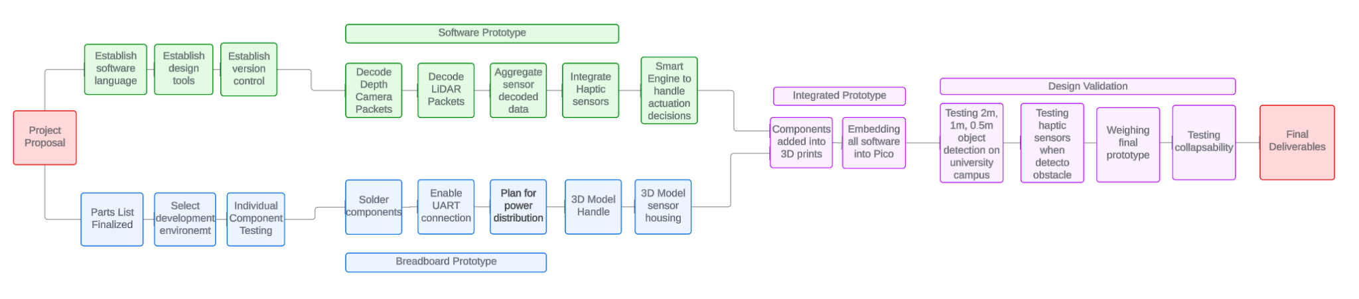

Figure 13: Pert chart for the project schedule. This schedule begins with our initial project proposal to stakeholders, then splits off into two development phases. The hardware development phase is in the blue blocks. The software development phase is in the green blocks. The integration & test phase as well as design validation phase is in purple. The schedule ends with final deliverables in red. This chart was adapted to expand each phase into sub tasks.

## Updated validation and testing procedures (1 page; 10 points)

The main objectives of GUIDE as stated in the sections above are to provide increased mobility to the visually impaired through obstacle detection and user alerts. These objectives are vital to the success of GUIDE and in the independence of those with visual impairments. Given our environment is a college campus we will be conducting all testing at Texas A&M University. We have allotted 3-4 weeks of integration testing as well as design validation.

The first objective is testing for mobility. GUIDE must be less than 2 pounds. To test this we will weigh the final design to ensure it is lightweight and every user regardless of physical ability and age is able to use GUIDE. In addition to weighing the cane we will walk with GUIDE around the university campus to ensure it does not cause strain to the user's arm for 20 minutes. GUIDE must be collapsable to ensure it is portable and users can store the cane easily. To test this we will ensure the final design can be collapsed and held in one hand, as the original design. Lastly, to ensure mobility, the team will power GUIDE for 3-4 hours to ensure it is fully functional for the duration of the battery’s life. At each half hour we will assess how the accuracy of each component has changed when yielding results.

The second objective of GUIDE is to detect obstacles using a LiDAR and depth camera. To ensure each component is functioning properly we will check each separately. We will test the depth camera by ensuring the videos and images output reflect the real-time environment being seen by the user. To do this we will test the camera attached to a computer with graphical capabilities and walk through the campus. This will be done in sunny, cloudy, rainy weather, and temperatures ranging from 90 degrees to 60 degrees. The LiDAR will be tested similarly but we will output the distances from obstacles using a computer terminal. To ensure these values are accurate we will physically measure the distance using a tape measure. These tests will be completed on the college campus in sunny, cloudy, rainy weather, and temperatures ranging from 90 degrees to 60 degrees. Once each component is tested separately we will integrate the two and ensure functionality does not become compromised. As GUIDE must detect obstacles 2m away from the user we will walk through the campus and run five tests. The first test will ensure if there is no obstacle 2m away the cane will not alert the user. The second test will place various obstacles within 2m of GUIDE. We will test using common obstacles on a college campus such as, curbs, medians, sidewalk barriers, pedestrians, bikes, scooters, squirrels, and cars. The third test will use the same subjects as test 2 but the distance between the obstacles will decrease to 1m. The fourth and fifth tests will use the same subjects as test 2 but the distances will decrease to 0.5m and 0m. As stated earlier, these tests will be completed in sunny, cloudy, rainy weather, and temperatures ranging from 90 degrees to 60 degrees. During these five tests we will print the distance and view the images/videos through a computer with graphical capabilities.

The last objective of GUIDE is to alert users when an obstacle is 2m, 1m, 0.5m, and 0m away and have less than a 0.5 second delay. The user must be alerted within 0.5 seconds there is an obstacle in front of them. To ensure this is true, we will collect timestamps and telemetry from the software of when the obstacle was detected and at what time the rumblers on the handle started vibrating. If the delay is not within 0.5 seconds we will look into optimizing the software to ensure latency meets the requirement. In addition to testing delay time, to ensure the user is alerted according to our requirements and objectives we will test the intensity of the rumbler at different distances. There will be a total of 4 tests where we will first test if the rumblers are triggered once an obstacle is detected 2m away from the user. The next test will be completed similarly but we will measure 1m away from the obstacle and ensure the rumblers increase the intensity of the vibrations. Next, we will measure 0.5m between GUIDE and the obstacle and make sure the rumblers are triggered with an even higher intensity. Lastly, once the obstacle is 0m away we will test the rumblers and have them set as the maximum vibrations, per the users sensitivity levels.

When completing the integration and testing portion of the schedule we would have validated our design can detect obstacles 2m away, respond for distances 2m, 1m, 0.5, 0m within 0.5 seconds and can have full functionality for 3-4 hours without causing physical strain due to weight or collapsibility.

## Updated division of labor and responsibilities (2 pages; 10 points)

| Team Member | Task | Task Description | Due Date |
| --- | --- | --- | --- |
| Diana Canchola | Weekly Report 1-8 | Generate documentation on weekly progress made by the team and present to the professor and TA during class time. | Every Tuesday |
| Weekly Agendas and Focuses | Generate internal documentation for goals and focuses of the week. | Every Tuesday |
| LiDAR Python Script | Work with the software team to ensure our LiDAR script is functional on the Pico and in Python. | 10/15 |
| Smart Combined Sensor Data Script | Python script to aggregate both the LiDAR and depth camera data. | 10/31 |
| Jack Letsinger | Finalize and Order Parts | Identify all components needed in the project, order parts and ensure they arrive in a timely manner. | 10/24 |
| Configure Development Environment | Set up and host virtual machine(s) for data collection. | 10/13 |
| Test Sensor Capabilities | Verify that sensors are working orthogonal to the embedded environment, and are within specification for the project. | 10/12 |
| Oversee sensor integration | Properly incorporate sensors to the Pi Pico, ensure that power and other electrical factors are of sufficient quality. | 10/19 |
| Handoff to Software team | Finalize the state of the breadboard prototype with the intent of handing it off to the software team for optimization and fine-tuning | 10/22 |
| Jack Couture | LiDAR Python Script | Work with the software team to ensure our LiDAR script is functional on the Pico and in Python. | 10/15 |
| Depth Camera Python Script | Update the original depth camera script to be in Python and ensure functionality. | 09/26 |
| Compare Gathered Data with Measured Values (Plot Data) | Compare the data gathered by both cameras from the same point to the measured value to see the accuracy of each and note any differences. | 10/24 |
| Haptic Sensor Activation Script | Python script to trigger haptic sensor feedback to the user and a way to differentiate the frequency of the vibrations. | 10/24 |
| Smart Combined Sensor Data Script | Python script to aggregate both the LiDAR and depth camera data. | 10/31 |
| Alyan Tharani | 3D Model of GUIDE Handle | Developing and printing the 3D model of the handle iteratively. | 10/22 |
| 3D Model of GUIDE Sensor Housing | Developing and printing the 3D model of the sensor housing iteratively. | 10/31 |
| Noah Kilpatrick | Depth Camera Decoding Packets | Decoding data packets from the Depth camera extracted by the hardware team. | 09/26 |
| LiDAR Decoding Packets | Decoding data packets from the LiDAR extracted by the hardware team. | 10/17 |
| Haptic Sensor Activation Script | Python script to trigger haptic sensor feedback to the user and a way to differentiate the frequency of the vibrations. | 10/24 |
| Smart Combined Sensor Data Script | Python script to aggregate both the LiDAR and depth camera data. | 10/31 |
| Ryan Wu | Soldering and component Integration | Solder electronic components for best use during testing. | 10/17 |
| Sensor Integration | Properly incorporate sensors to the Pi Pico, ensure that power and other electrical factors are of sufficient quality. | 10/15 |
| Breadboard Prototype | Completed the integration of all sensors, microcontroller and power components. | 10/17 |

# Preliminary results (1-2 pages; 5 points)

Below are two demos the team conducted to do preliminary testing on our sensors. These demos were designed to test UART connection with the Raspberry Pico, ensuring there is back and forth communication between the sensors and microcontroller. The first demo had the Raspberry Pico connected to the Depth Camera and LiDAR. There was an LED connected to the Pico to ensure there was a connection made and a message was received from the sensors.

The second demo included testing the LiDARs distance capabilities. Our requirements are set at being able to detect obstacles 2m away, the demo proves that. The demo shows one of our team members move into and out of the frame at around ~2m distances. The result was the LiDAR was reading the wall in the distance at ~6m meters and when the person moved into the frame the LiDAR changed its distance measurement to ~2m.

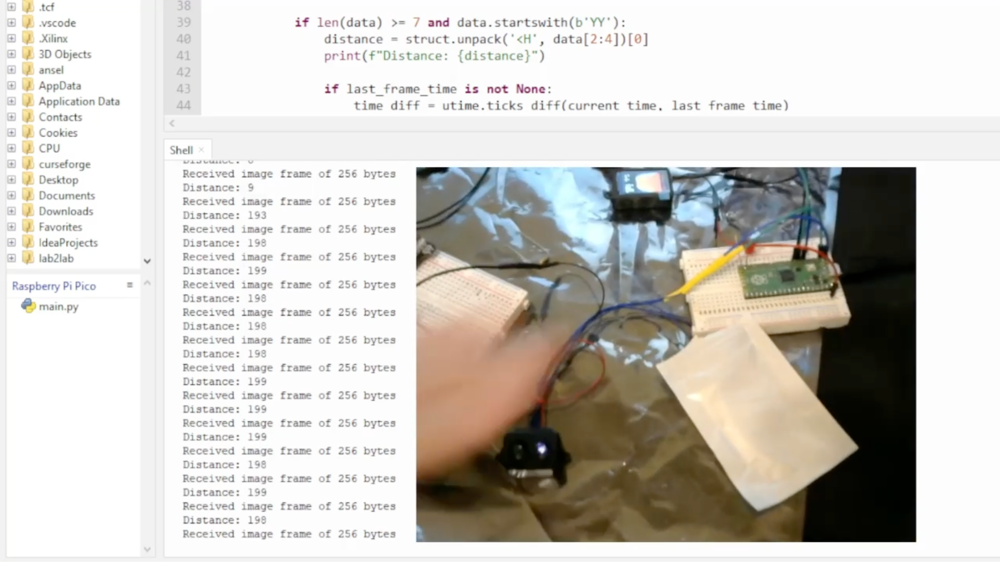

*Figure 14:* This figure shows one of the first demos of the breadboard prototype.

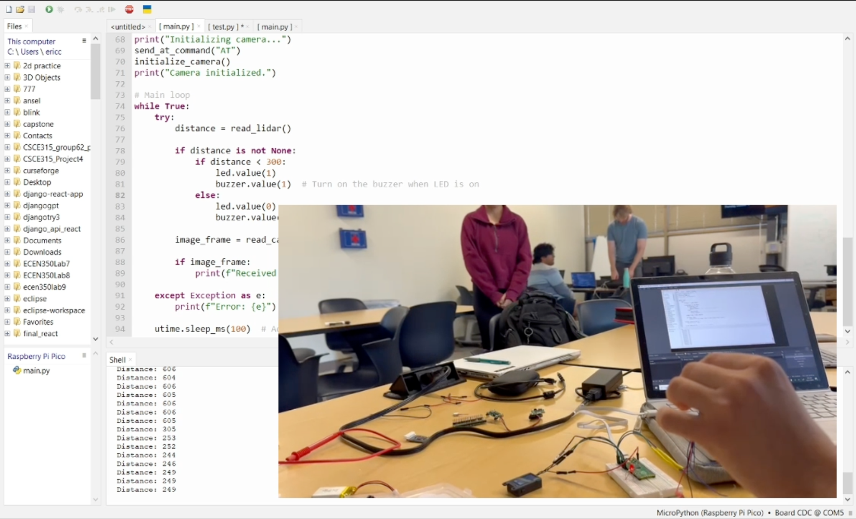

*Figure 15: This figure shows the second demo testing the LiDAR distance capabilities.*

# References

* [1] World Health Organization, Aug. 10 2023, “Blindness and Visual Impairment”, World Health Organization,[Online],Available: <https://www.who.int/news-room/fact-sheets/detail/blindness-and-visual-impairment>
* [2] Snowflake_tvi, "Lazarillo: A Free Accessible GPS App for the Blind and Visually Impaired," Perkins School for the Blind, Sep. 19, 2024. [Online]. Available: https://www.perkins.org/resource/lazarillo-free-accessible-gps-app-blind-and-visually-impaired/ (accessed Sep. 19, 2024).
* [3] MathWorks, "SLAM (Simultaneous Localization and Mapping)," MathWorks, Sep. 19, 2024. [Online]. Available: https://www.mathworks.com/discovery/slam.html (accessed Sep. 19, 2024).
* [4] I. Papagianopoulos, G. De Mey, A. Kos, B. Wiecek, and V. Chatziathasiou, "Obstacle Detection in Infrared Navigation for Blind People and Mobile Robots," Sensors, vol. 23, no. 16, p. 7198, Aug. 2023, doi: 10.3390/s23167198.
* [5] feelSpace GmbH, "feelSpace naviGürtel," feelSpace, Sep. 19, 2024. [Online]. Available: https://feelspace.de/en/ (accessed Sep. 19, 2024).
* [6] WeWalk, "WeWalk - Brand New Smart Cane 2," WeWalk, Sep. 19, 2024. [Online]. Available: https://wewalk.io/en/ (accessed Sep. 19, 2024).
* [7] Security Robotics, "SPOT – the allrounder," Security Robotics, Sep. 19, 2024. [Online]. Available: https://security-robotics.de/en/allrounder-spot (accessed Sep. 19, 2024).

# 